# 

Lead with Empathy

Training

Chantal le Roux

Principal Program Manager, Culture

AWS

**Lead with Empathy**

Empathy – an Essential Leadership Skill 3

What is a Psychologically Safe Workplace? 5

Empathy Blockers 9

Strategies for Calm 10

Active Listening 10

Be a Learner, not a Knower 12

Relational Interaction 12

Who We Are is How We Lead 13

Strive to be Earth’s Best Employer 15

# Empathy – an Essential Leadership Skill

**What is Empathy?**

Empathy is the **skill**of understanding the **thoughts and feelings of another person**.

It's not about *identifying*with their experience - perhaps you've never been in their situation, and even if you have, you've likely experienced it differently. Empathy is about understanding the thoughts and feelings that *underpin*another person's experience.

We all know what it’s like to be judged and to feel like our experience isn’t valid – it breaks connection and trust. And when we feel truly understood and our experience is validated, it builds connection, trust and a sense of belonging.

**Empathy isn't a trait that you either have or don't have;**

**It's a skill that we can develop**

**and it's essential for building meaningful relationships.**

We have a **Principal Engineering tenet** and a **Leadership Principle**to underscore the importance of **meaningful relationships - the foundation of our organization.**

Principal Engineer Lead with Empathy Tenet

Principal Engineers shape an inclusive engineering culture where others are heard, feel respected, and are empowered.

We are conscious of how words and demeanor impact others, especially those with less influence; we take responsibility for that impact, intentional or otherwise.

Our work builds productive relationships across teams and disciplines, and across a wide range of life experiences.

Amazon Leadership Principle

Leaders work every day to create a safer, more productive, higher performing, more diverse, and more just work environment. They **lead with empathy**, have fun at work, and make it easy for others to have fun.

Leaders ask themselves: Are my fellow employees growing? Are they empowered? Are they ready for what’s next? Leaders have a vision for and commitment to their employees’ personal success, whether that be at Amazon or elsewhere.

​

**Leading with empathy is about developing skills to use our emotions intelligently in order to create a psychologically safe workplace.**

**Psychological safety** is the belief that you won’t be humiliated, ignored, blamed or punished for asking questions, asking for help, sharing your ideas and opinions, doing things differently, or making a mistake. It's fundamental to creating a workplace that fosters inclusion, learning, and innovation*.*

**From Empathy to Innovation**

1. **Empathy builds meaningful relationships**

We all have a fundamental need to belong. We experience belonging through meaningful relationships, for which empathy is essential.

1. **Meaningful relationships create psychological safety**

Meaningful relationships create an environment of mutual trust and respect, in which we feel safe enough to learn, take risks, and challenge the status quo.

1. **Psychological safety allows for innovation**

Psychological safety allows high-performing teams to thrive. We celebrate intelligent failure and get to disruptive innovation.

*Leading with Empathy is crucial for optimizing our potential as an organization, and ensuring our success is sustainable.*

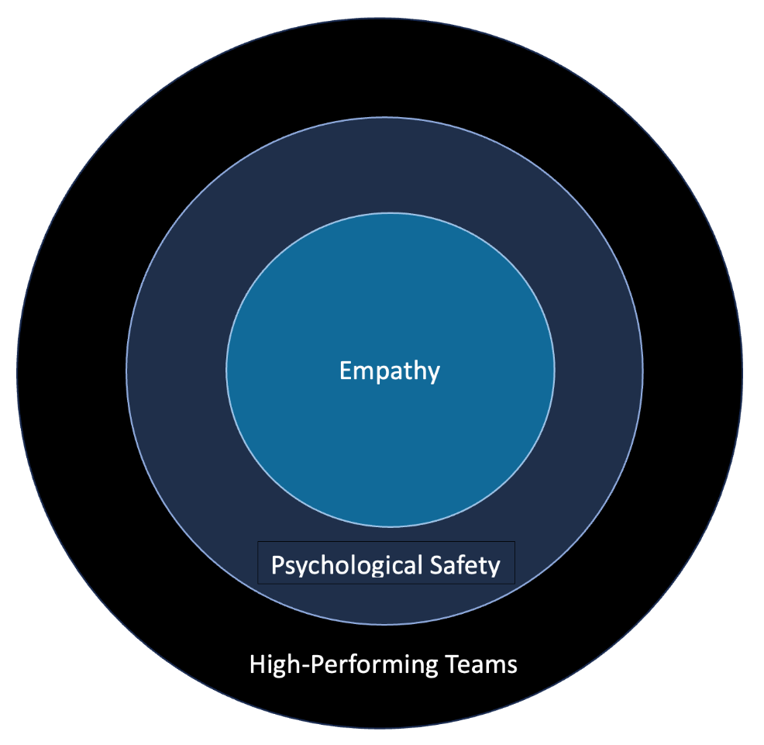

# What is a Psychologically Safe Workplace?

**Influence of Psychological Safety on Performance Standards[1]**

Psychological safety is not about creating an “anything goes” workplace, where we don’t Insist on the Highest Standards and Deliver Results. Research shows that a high level of psychological safety promotes high performance in a wide range of industries and work environments. Teams who make more mistakes are more successful, because creating a workplace in which people feel safe enough to take risks is key to innovation.

Google’s Project Aristotle[2] explored what makes a team effective. The findings are aligned with Amy Edmondson’s extensive research in team performance, and indicate that psychological safety and performance standards are two separate and equally important dimensions that affect the performance of teams.

|  |  |  |
| --- | --- | --- |
|  | **Low Standards** | **High Standards** |
| **High Psychological Safety** | Coasting Zone | **Peak Performance Zone** |
| **Low Psychological Safety** | Apathy Zone | Anxiety Zone |

* **Apathy Zone**: When both psychological safety and performance standards are low, people lack motivation and prioritize self-protection. The main aim is to get through the day with minimal exertion. This is about bringing as little of yourself to work as possible.
* **Coasting Zone:** When we have high psychological safety and low performance standards, people may feel comfortable being themselves at work, but they aren’t motivated to seek challenges and develop themselves. They don’t feel engaged, fulfilled or inspired to innovate.
* **Anxiety Zone:** When psychological safety is low and performance standards are high, people experience anxiety, as they’re under pressure to perform, but don’t feel safe enough to speak up, ask questions, and ask for help. This is likely to lead to an unsatisfying work environment, and is a root cause of burnout, as well as preventable failures.
* **Peak Performance Zone:** When both psychological safety and performance standards are high, people feel safe enough to contribute in meaningful ways, collaborate, challenge the status quo, and innovate. This is the workplace that actively Insists on the Highest Standards and Hires & Develops the Best, creating an inclusive environment where high-performance teams thrive.

**Without psychological safety**, we can’t be our authentic selves, we don’t feel like we’re a valued part of the team, we don’t experience inclusion, and aren’t going to optimize our potential in the workplace. When an organization is fear-based, cooperation, analytical thinking, problem-solving and creativity are inhibited. **Learning and innovation are stifled**.

Leading with Empathy creates psychological safety, whereas Armored Leadership creates psychological threat:

|  |
| --- |
| **Armored Leadership** |
| When we experience psychological threat, we go into self-protection mode – we armor up and engage in negative competition with each other, zero-sum thinking, we’re on high alert for hidden agendas and manipulative behaviour. This is the opposite of teamwork – it can feel like a fight for survival.  As part of a self-protection strategy, our actions are shaped by beliefs like:   * If I don’t want to look stupid, I don’t ask questions * Don’t want to look incompetent, don’t admit to mistakes * Don’t want to be labelled disruptive, don’t make suggestions   This is how **psychological threat inhibits cooperation, learning, and innovation.** |
| **Superficial Relationships** |
| When we experience psychological threat, emotional armor becomes essential for survival.  While many of us may think that we’re thinking, rational beings, who sometimes feel emotions, we’re really emotional beings who sometimes think! **When we shut down our emotions in the workplace, we’re not able to show up as our authentic selves.**  This means we don’t engage fully or contribute to the best of our ability. It also means that our interactions are limited and transactional, as opposed to relational, resulting in superficial relationships in the workplace. |
| **Exclusion** |
| We are social creatures, wired for connection, and we have a foundational **need for belonging**. If we can’t connect with each other authentically, we can’t experience belonging. When we don’t feel seen and valued for who we are, we don’t experience inclusion.  Our diverse workforce is key for innovation, but without inclusion, we experience a lack of motivation and satisfaction, which can lead to burnout and ultimately to us leaving the organization. |
| **High Risk-Aversion** |
| When we experience high psychological threat, productivity is often pegged to self-worth, which means we don’t feel safe enough to be wrong or fail. **Failure is not framed as a learning experience but as an execution problem.** We may not even feel safe enough to ask for clarity or help, which means we become risk-averse – we play it safe and small, and are not able to learn, experiment or innovate. |
| **Reactive Innovation** |
| Psychological threat inhibits innovation, as we don’t feel safe enough to learn, grow and challenge the status quo.  Questioning indicates a hidden agenda or a lack of respect, and people are defensive and closed-minded. This self-protection mode means that we lead *reactively*.  Without psychological safety, we cannot realize our full potential, **intellectual and emotional diversity will at best remain dormant, and at worst deepen the existing divides.** |

|  |
| --- |
| **Leading with Empathy** |
| Leading with Empathy creates psychological safety – the conditions for **high-performing teams to thrive** and lead *proactively*, which is key to innovation. |
| **Meaningful Relationships** |
| Proactively creating psychological safety means we notice when people are left out, **we care about each other’s wellbeing**. We recognize the importance of authentic interactions in the workplace, and we hold a **compassionate space for tough conversations**.  **Vulnerability as an essential leadership skill** – this is about readily admitting to not having all the answers, learning from diverse perspectives, and caring about how people feel in the workplace. It’s this kind of brave leadership that builds meaningful relationships, giving people a sense of belonging, and allowing them to bring their **best selves to work.**  Brené Brown, a research professor at the University of Houston, has conducted extensive research on the role of empathy and vulnerability in leadership. As she explains:  ***“It takes courage to be vulnerable. There is no situation where being vulnerable didn't require courage.”[3]*** |
| **High Risk-Tolerance** |
| Psychological safety allows us to take ownership of our learning journey, as we experiment, fail, learn, iterate, and try again. Expectations are clear and we know our worth.  Healthy striving is role-modelled, and rest and recovery encouraged. This creates a resilient workforce with a high risk-tolerance, and we’re able to **Think Big** and **Deliver Results**. |
| **Inclusion** |
| When we create a psychologically safe workplace, we unlock people’s potential. People feel like they **belong** and want to stay. We ultimately build inclusion and are able to **harness the power of a diverse workforce**. |
| **Disruptive Innovation** |
| A strong feedback culture that is based on mutual respect enables us to **focus on getting it right, as opposed to being right**. We feel safe enough to welcome constructive, direct feedback, because we know that this is about helping us be our best selves at work.  This allows us to avoid *preventable* failures by encouraging us to ask questions, share data, to report on what’s really happening. Intelligent failures are encouraged, as they are rooted in high standards that challenge the status quo. We are encouraged to analyze and learn from these failures – a process that often leads to **disruptive innovation**. |

*The experience of* ***belonging*** *lights us up,* ***inspires*** *us to be our best selves, and leads to* ***disruptive innovation****.*

***Armor is heavy and clunky - it keeps us small, wastes resources and suffocates creativity and innovation.***

When it comes to Psychological Safety you can either**lead the way** or **get in the way**

-Timothy R. Clark, The 4 Stages of Psychological Safety

# Empathy Blockers

Before we learn practical strategies for Leading with Empathy, it's important to understand *what gets in our way*of being the leaders we want to be.

**Common blockers include:**

1. **Lack of focus**

Paying attention is the first step in practicing empathy. *We can't respond to that which we don't notice.*

Email notifications, reminders from your phone, noises in the neighbour's yard, and the constant chatter in your head are common empathy blockers. Consider what you could do to be more present and allow yourself to access the information you need to lead with empathy.

1. **Stress**

When we're stressed, we're in survival mode. Our attention is on ourselves and we're not able to consider the perspectives and feelings of others.

1. **Insecurities**

Our insecurities are often based on a belief that we're not good enough. We then strive for perfectionism and fear what we can't control. **Empathy requires us to lean into the discomfort** of not having all the answers, and resisting the urge to fix the other person or their situation.

When we lack focus, are stressed, or are feeling insecure, we miss opportunities to Lead with Empathy. We respond to others in a way that **undermines trust, builds resentment and breaks connection**. We can think of these as **empathic misses**.

Consider the examples below, and think of a time that you experienced, or created an empathic miss - *what could we do differently to build connection and trust?*

|  |  |
| --- | --- |
| **Sympathy**  *Oh, you poor thing!* | **Judging**  *How could you let that happen?* |
| **Over-reacting**  *Wow – that’s awful! I would just die!* | **Expectations**  *You’ll be perfect – you always are!* |
| **Comparing**  *You think that’s bad! One time…* | **Fixing**  *Here’s what you need to do* |

Now that we're aware of potential empathy blockers, let's explore what we can do to address them.

# Strategies for Calm

|  |  |  |
| --- | --- | --- |
| Find a **breathing practice** that works for you. Reach out in our [Slack channel](https://slack.com/app_redirect?channel=lead-with-empathy) for ideas. | If you tend to grind your teeth, a **calming ball** is a healthier option! | **Focusing on sensation**, like slowly drinking cold water, can help us to shift our emotions. |

Invest time into finding a strategy that works for you. **Practice it daily**, so that you can count on it when you need it most.

# Active Listening

**Active listening is an essential leadership skill** and a powerful strategy for Leading with Empathy. Through listening, we understand *how*the other person feels, as well as *why*they feel that way.

We all know what it's like to not be listened to - it doesn't make you want to contribute, and it erodes trust. And when we are really listened to, we contribute more than we planned, we're encouraged to Think Big, and we're inclined to reciprocate and actively listen to others.

**Active Listening allows us to:**

1. Earn Trust
2. Build connection and a sense of belonging
3. Think Big as we listen for diverse perspectives
4. Dive Deep in understanding fundamental issues and create sustainable, innovative solutions

Influence through listening -

***How you listen* says a lot more about your leadership than anything you could *say*.**

**Active listening means listening to *learn*, as opposed to listening to *respond*.**

1. No interrupting
2. Listen without an agenda
3. Listen without planning your response
4. Listening without building an argument
5. Learn and Be Curious

***Active listening is a new for many of us - here are a few tips to help build this skill:***

|  |  |
| --- | --- |
| **Distraction-free zone**  Turn off any distractions (phone/ e-mail/ messenger) to give your undivided attention. | **Imagine you're interviewing**  A familiar mindset of discovery |
| **Think long-term**  Listening builds trust and unlocks potential. | **Take notes**  Let the speaker know that you're taking notes as you don't want to miss what they say. |
| **Commit to learning**  Even when the content isn't new to you, listen to learn. You may discover a new perspective. | **Repeat back**  Summarize what you've understood and check for understanding. |

Practice active listening, and notice what challenges you - it could be that you interrupt, that you immediately want to fix the issue, that you feel you need to have a response ready, or that you get distracted. Writing down the barriers you experience to active listening will help you get clear on what you need to work on. And when you don't get active listening right, **lead with vulnerability** and admit that that you weren't listening.

**Apologize**and let them know that you really want to hear what they have to say. They'll appreciate your willingness to try again. **Compassion is key!**

# Be a Learner, not a Knower

**While many of us are used to being the experts in our field, Leading with Empathy is about becoming an expert Learner.**

**Consider these strategies for being a Learner - *how could you implement these on a daily basis?***

1. **Admit when you don’t know**

Admit when you don't have all the answers - this **Earns Trust** and allows others to do the same.

1. **Share what you’ve learned**

Share what you've learned from your mistakes - not just the sensational mistakes, but the mundane ones too. This fosters a culture of**learning and experimentation**.

1. **Ask what support looks like**

Instead of assuming you know how to support someone, explain that you want to support them, and **ask what they need from you**. This encourages open communication and clear expectations.

# Relational Interaction

**Leaders create psychological safety through *relational* interaction, as opposed to *transactional* interaction.**

1. **Show that you care**

**Ask how your colleague is and listen with genuine interest. If they share something meaningful to them, make an effort to remember, and follow-up if appropriate. Care generates mutual trust and resilience.**

1. **Compassionate feedback**

**Give feedback that is clear, constructive and compassionate. Separate comments on the aspects you appreciate from those that need work. Leading with empathy means that feedback empowers people to optimize their potential.**

***Tip*: Before contributing feedback on a document, pause to acknowledge that a human being put a lot of effort into this, regardless of what you think of it. Ensure your feedback is clear and kind.**

1. **Ensure people know their worth**

**Don't assume people know their worth, and don't wait for the annual review to discuss feedback. Explain why you value their contributions and what you learn from them on a regular basis.**

# **Who We Are is How We Lead**

**Every interaction we have is an opportunity to Lead with Empathy.**

That includes the interactions we have with ourselves - how we talk to ourselves, and how we react our own emotions and needs.

1. **Emotional literacy**

Accurately labelling our emotions **gives the emotions less control over us**, and is key for processing them. Developing our emotional literacy also enables us to understand and label the emotions of others, and to communicate our understanding back to them. This lets them know that**they are seen and valued**, and**cultivates belonging**.

*Most of us weren’t taught how to accurately identify our emotions, especially while we’re feeling them. Practice throughout the day with a range of emotions.*

The ***Feelings Wheel***(Gottman Institute) is an inspiring resource for practicing naming your feeling in the moment:

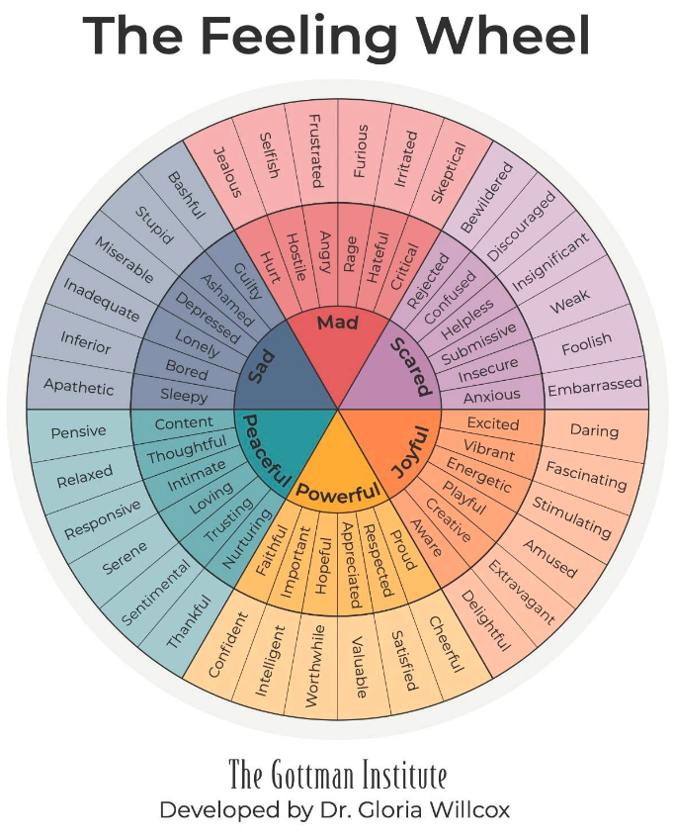

1. **Self-compassion**

Self-compassion is essential for Leading with Empathy, and it's also one of the hardest skills to learn. By practicing compassionate feedback with *ourselves*, we're better able to support and develop others.

Build the **habit of reflecting on your interactions**, using them as learning opportunities:

1. What did I contribute?
2. *How*did I contribute?
3. Which behaviours built inclusion?
4. What do I want to change?
5. What resources/ support do I need?
6. Ask for help

**Asking for help takes courage**. When we ask for help, we send the message that Leading with Empathy is a learning journey for all of us. We role-model vulnerability and**create psychological safety**.

# **Strive to be Earth’s Best Employer**

The [Strive to be Earth’s Best Employer (STBEBE) e-learning](https://atoz.amazon.work/m/learn/transcriptdetail?trainingId=TCRKN1T202211111933390c0c4111&trainingLms=LEARN) unpacks the key concepts of this Leadership Principle (LP), explores its relationship with our other LPs, and provides a practical framework for implementing this LP on a daily basis.

**Leading with Empathy is about leading with humanity.**

1. Adapted from: Edmondson, A.C. 2018. *The Fearless Organization: Creating psychological safety in the workplace for learning, innovation, and growth*. Kindle Edition.
2. <https://rework.withgoogle.com/print/guides/5721312655835136/>
3. Brown, B. 2018. *Dare to Lead: Brave work. Tough conversations. Whole hearts*. Kindle Edition.